# ****Project Documentation: EGYPTOUR****

## ****Introduction****

EGYPTOUR is a digital platform designed to revolutionize the tourism experience in Egypt. By connecting tourists with local activities, accommodations, and souvenir vendors, the platform offers a seamless and interactive way to explore Egypt. This document outlines the project's objectives, scope, planning, system design, implementation, and evaluation criteria to ensure the successful development and deployment of the system.

# Project Proposal: EGYPTOUR

## Overview of the Project

EGYPTOUR is a comprehensive online platform designed to connect tourists with various activities, accommodations, and souvenir sellers across Egypt. The platform acts as a mediator, providing an easy way for visitors to explore and find trips, view available activities, purchase souvenirs, and manage their travel plans efficiently.

## Objectives

- Provide a seamless and user-friendly booking experience for tourists.

- Facilitate access to local activities, hotels, and travel services.

- Create an online marketplace for souvenir sellers.

- Enhance the tourism experience in Egypt through digital transformation.

- Ensure transparency in pricing and service offerings.

## Scope

- User Registration & Authentication – Tourists can sign up and manage their profiles.

- Filtering Options – Users can filter by location (governorates), activity type, hotels, and available services.

- Souvenir Marketplace – Vendors can list and sell souvenirs.

- Flight & Travel Plan Integration – Users can browse flight options and tour packages.

- Shopping Cart & Order History – Users can add items to their cart and view past orders.

- Secure Payment Integration – Online payment for bookings and purchases.

- User Reviews & Ratings – Tourists can leave feedback on activities and purchases.

# Project Plan: EGYPTOUR

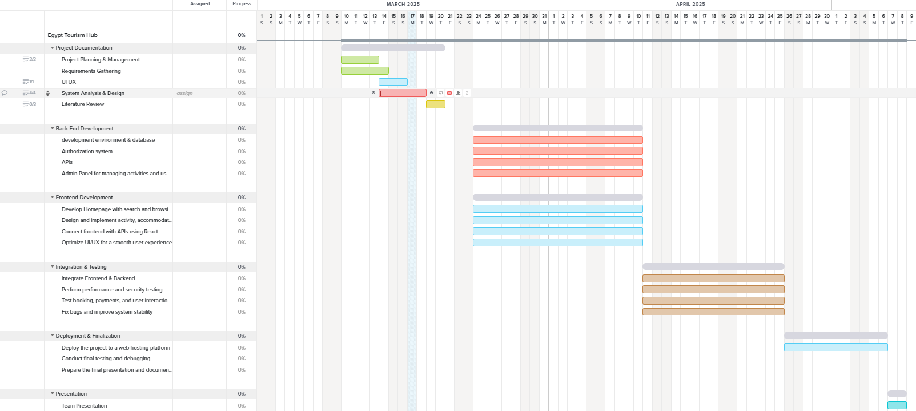

## Phase 1: Research & Planning

- Project Planning & Management

- Develop a comprehensive project proposal outlining objectives and scope.

- Create a detailed project plan, including timeline, milestones, and deliverables.

- Assign tasks and roles to team members.

- Identify potential risks and develop a mitigation strategy.

- Define Key Performance Indicators (KPIs) to measure project success.

- Literature Review

- Collect feedback and evaluation from lecturers.

- Identify areas for improvement and implement suggested enhancements.

- Establish final grading criteria based on documentation, implementation, testing, and presentation.

## Phase 2: Requirements Gathering & System Analysis

- Requirements Gathering

- Conduct stakeholder analysis to define user needs.

- Develop user stories and use cases for system functionality.

- Document functional and non-functional requirements, covering performance, security, usability, and reliability.

- System Analysis & Design

- Define the problem statement and project objectives.

- Create use case diagrams and descriptions to visualize system interactions.

- Develop software architecture using appropriate design patterns (e.g., MVC, Microservices).

- Design the database structure with an ER diagram, logical and physical schema.

- Map out data flow using DFDs, sequence diagrams, activity diagrams, and state diagrams.

- Create UI/UX wireframes and mockups to guide frontend development.

## Phase 3: Development & Implementation

- Frontend & Backend Development

- Implement user authentication and profile management.

- Develop filtering options for locations, activities, and services.

- Build a booking system for trips and activities.

- Integrate a souvenir marketplace and shopping cart functionality.

- Implement secure payment methods for transactions.

- System Deployment & Integration

- Define the technology stack (frontend, backend, and database technologies).

- Develop a deployment diagram and component diagram to map system distribution.

- Implement API documentation and CI/CD pipelines if applicable.

## Phase 4: Testing & Finalization

- Testing & Quality Assurance

- Conduct extensive test cases and test planning.

- Perform automated testing where applicable.

- Identify and resolve bugs through structured bug reports.

- Final Presentation & Reports

- Prepare user manuals and technical documentation.

- Develop a project presentation (PPT/PDF) summarizing the work.

- Optionally, create a video demonstration showcasing platform functionality.

## Phase 5: Deployment & Monitoring

- Final Deployment & Execution

- Upload all project documentation and code to GitHub.

- Provide installation steps, configuration instructions, and execution guidelines in a README file.

- Deploy the platform for public use, ensuring system uptime and performance.

- Post-Launch Monitoring & Updates

- Gather user feedback and implement improvements.

- Monitor system security and performance, applying necessary updates.

# Task Assignment & Roles

• **Project Manager & System Analyst** – Salma Mostafa  
Oversees the project timeline, team coordination, and system analysis.

• **Backend Developers** – Reem & Habiba  
Responsible for server, database, and API development.

• **Frontend Developers & UI/UX Designers** – Hager & Mohamed Essam  
Develop the user interface, user experience, and design wireframes.

• **Database Administrator** – Salma Mohamed  
Manages database design, optimization, and maintenance.

• **Quality Assurance (QA) & Testing** – **All Team Members**  
Everyone is responsible for testing features, identifying bugs, and ensuring the system runs smoothly.

# Risk Assessment & Mitigation Plan

- Technical Challenges: Risk of system bugs or performance issues → Implement rigorous testing phases.

- Data Security: User data breaches → Apply strong encryption and security protocols.

- User Adoption: Low initial engagement → Develop effective marketing strategies.

- Scalability Issues: Increase in users may overload the system → Use cloud-based solutions for scaling.

# Key Performance Indicators (KPIs)

• **System Uptime:** Maintain at least **97%-98% uptime**, with gradual improvements over time.

• **Response Time:** Ensure **API response times between 3-4 seconds** initially, optimizing it further later.

• **User Adoption Rate:** Target **200-500 active users** within the first 6 months.

• **Conversion Rate:** Achieve **20-50 bookings or purchases** within the first 6 months.

• **Customer Satisfaction Score:** Maintain at least **70%+ positive user feedback** based on reviews